Eskom Kimberley Strengthening Phase 4 Project: BOUNDARY-ULCO
Photos of the macro study area
Detail site photos are provided in the specialists reports

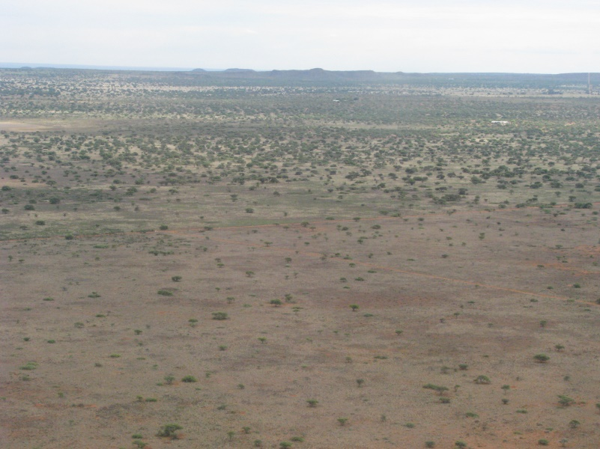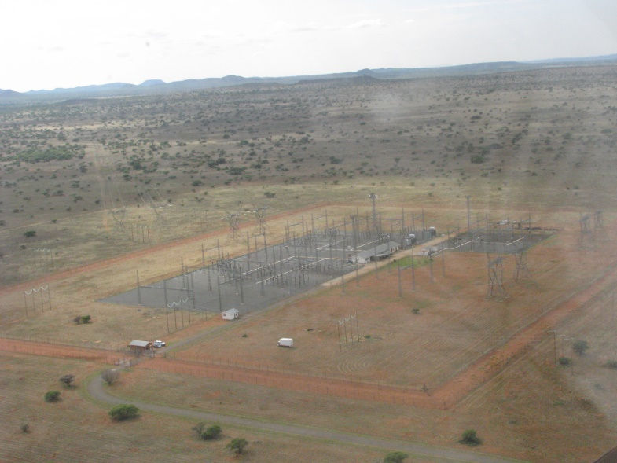
The area in the vicinity of the Boundary Distribution Substation Boundary Distribution Substation

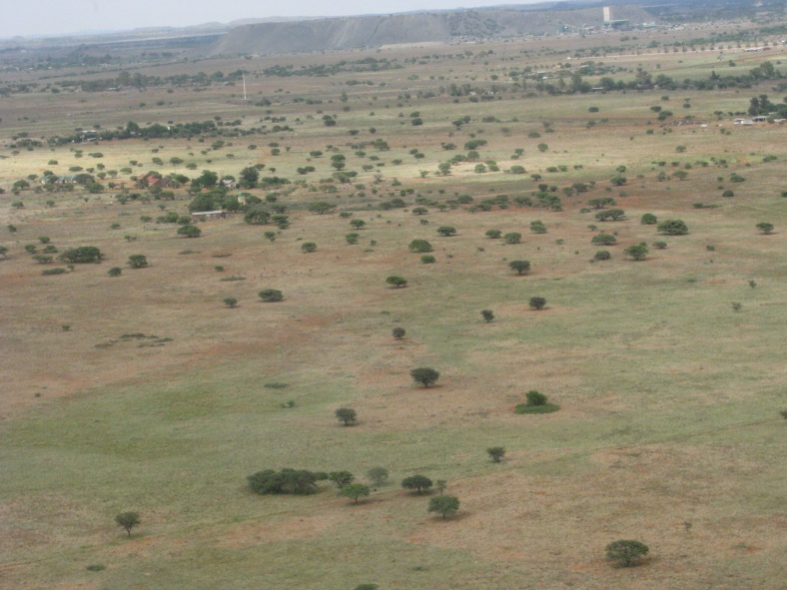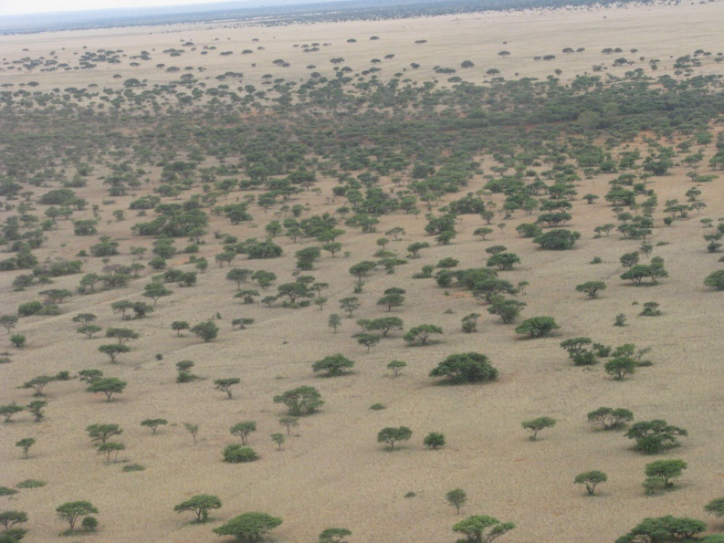
The landscape to the north of Kimberley, west of the Boundary Substation

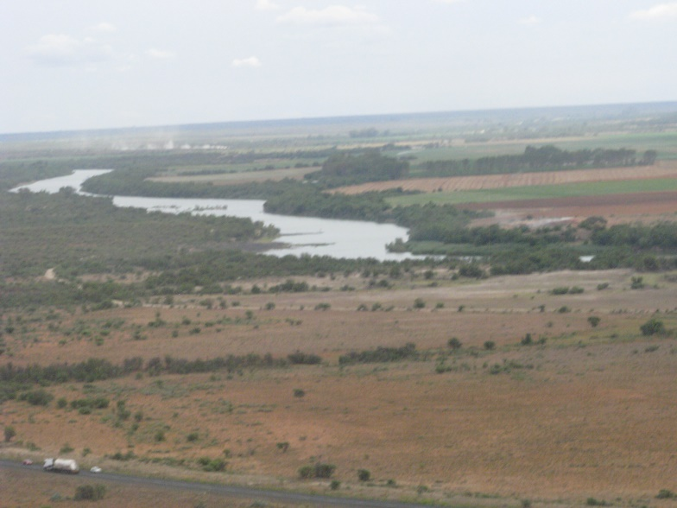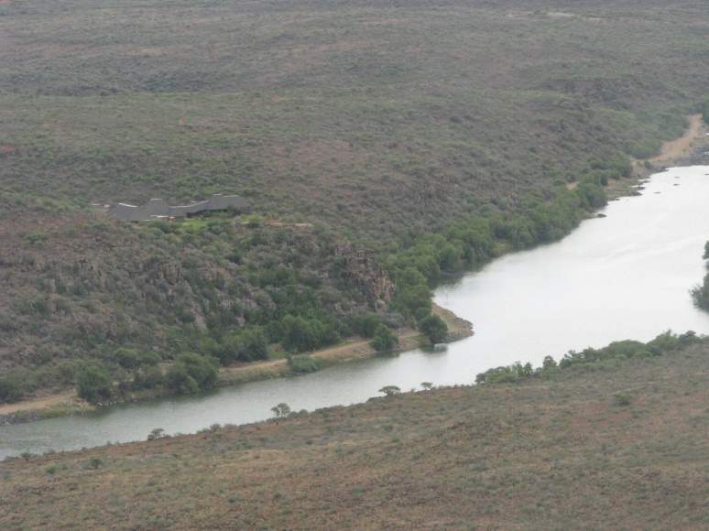
Route Alternative 3 will cross the Vaal River. An exclusive lodge is visible on the banks of the river (photo to the right)

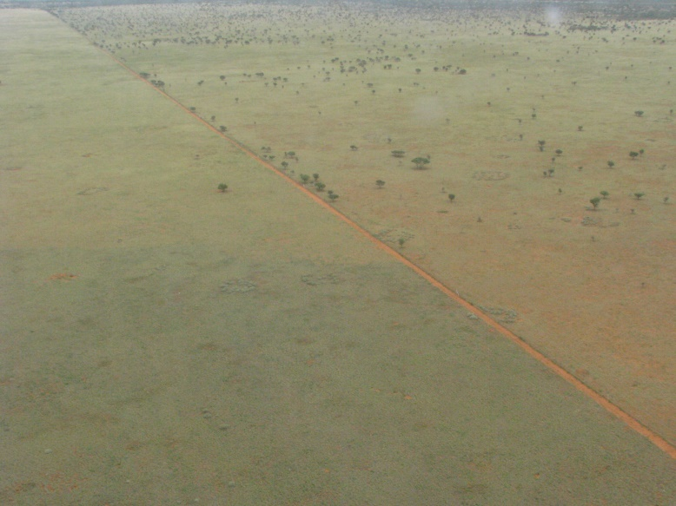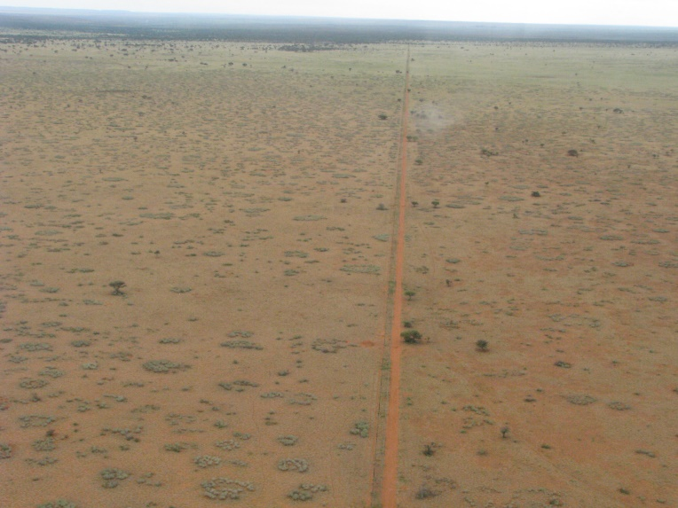
Typical landscape within the study area – clearing of farm fences can clearly be seen

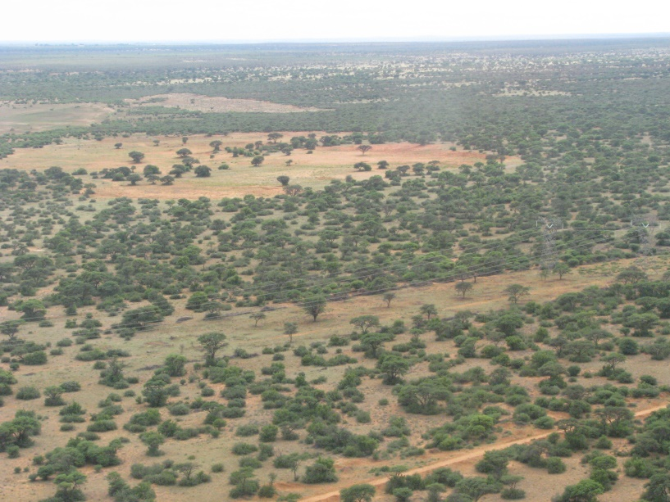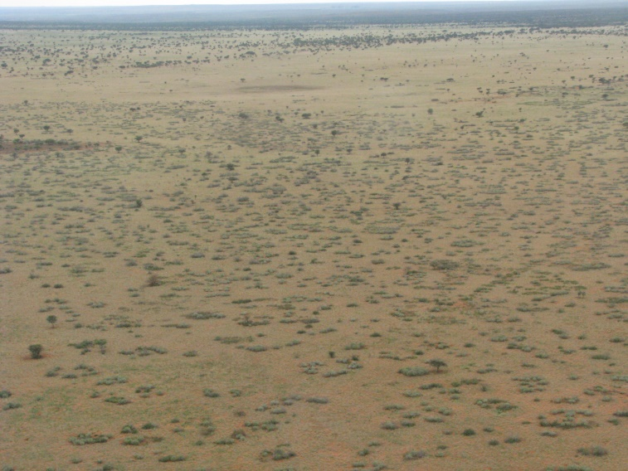
Natural vegetation and pans in the vicinity of the proposed routes

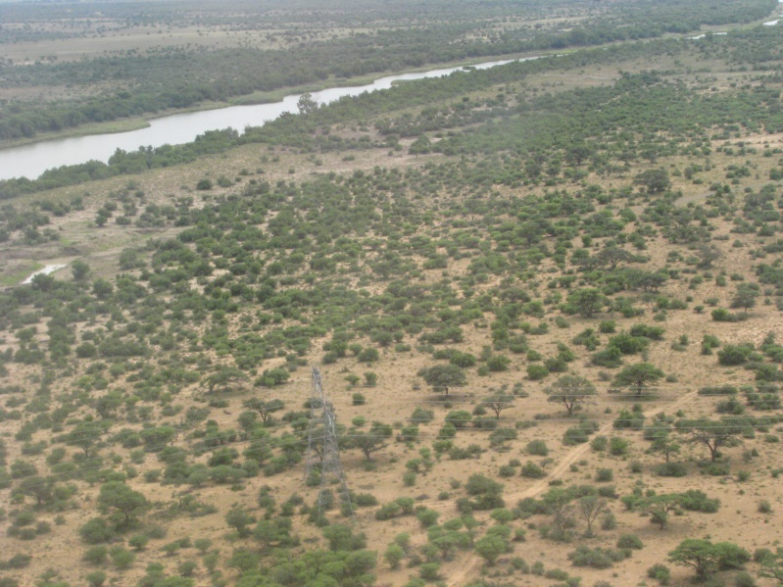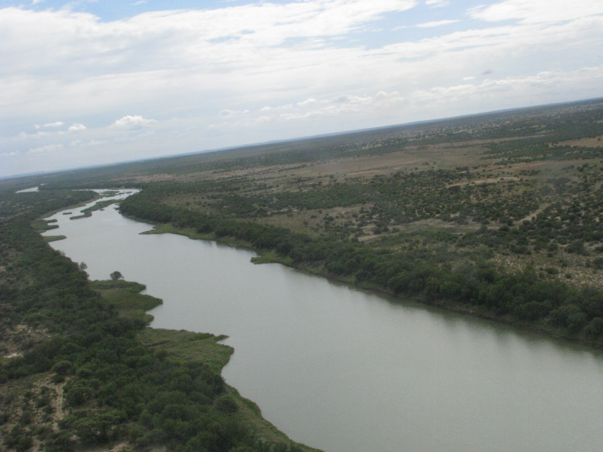
At the point where Route Alternative 1 & 2 could cross the Vaal River

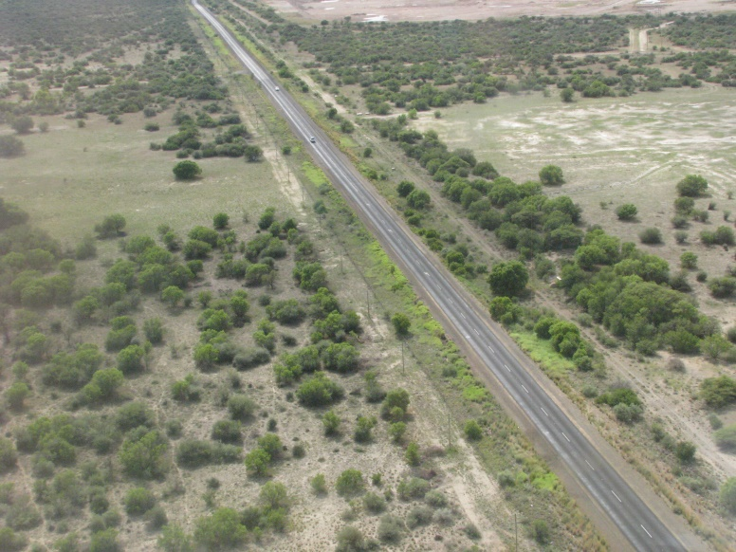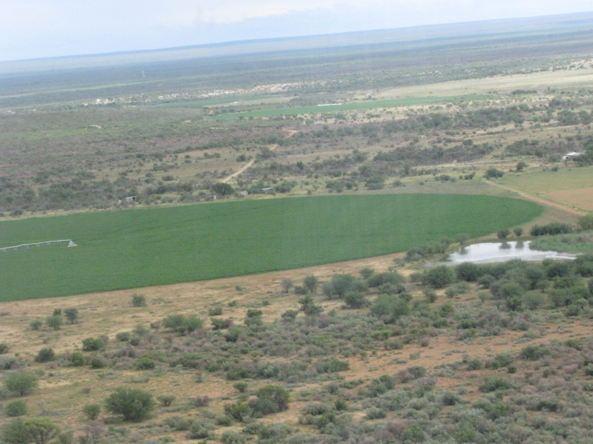
The R31 between Kimberley and Ulco and typical of farming activities within the study area

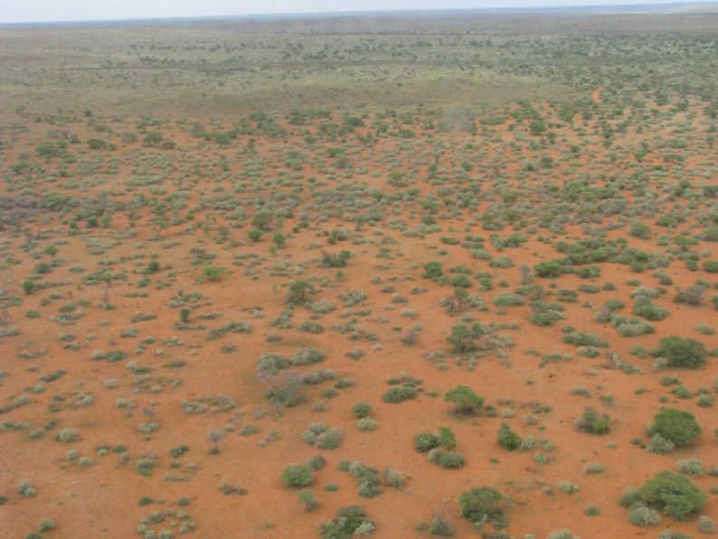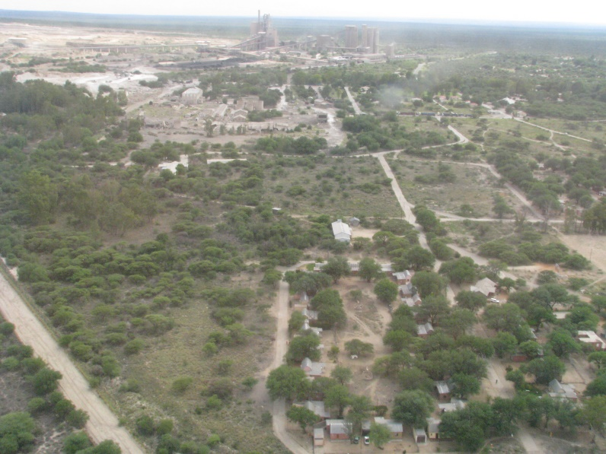
Natural vegetation within the study area Mining activities at Ulco

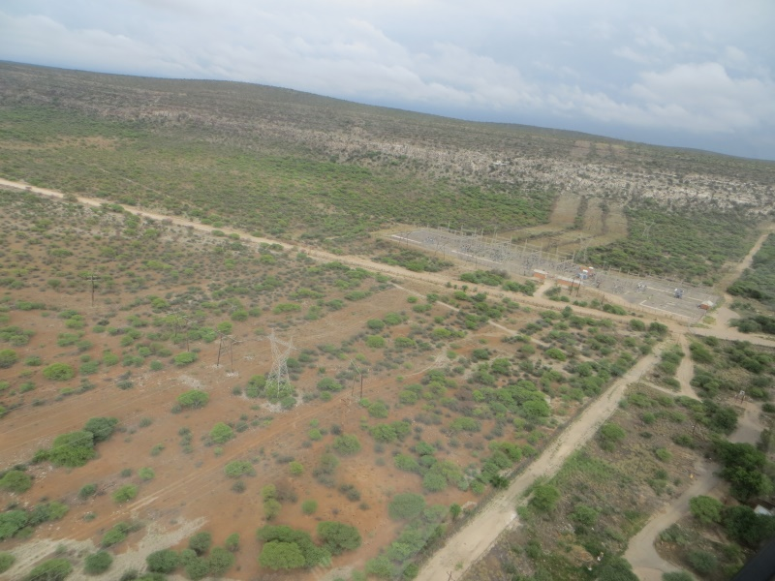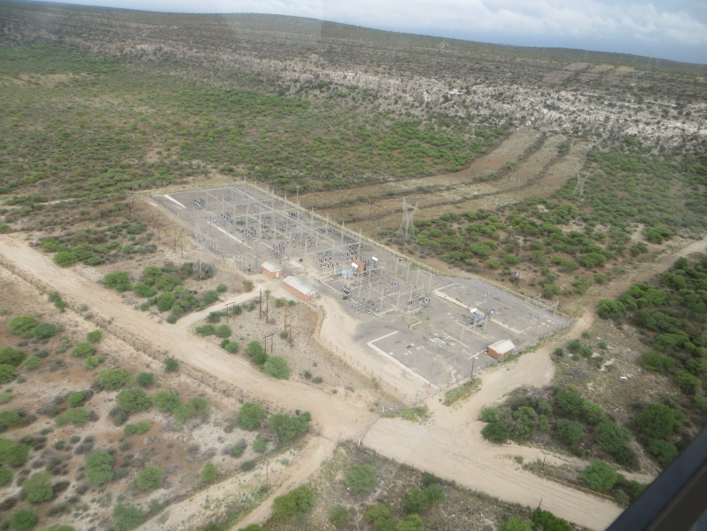
The Ulco Distribution Substation with the Gaarp Escarpment in the background.
Servitudes of existing lines where vegetation were cleared are clearly visible

